**Study of GCC**

**Program to demonstrate c++ program.**

**INPUT**

#include <iostream>

using namespace std;

int main()

{

int a, b, c;

cout << "Enter two integers\n";

cin >> a >> b;

c = a + b;

cout <<"Sum of the numbers: " << c << endl;

return 0;

}

**OUTPUT**

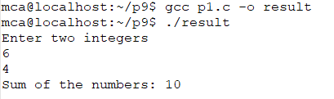

**Program to demonstrate g++ program.**

**INPUT**

#include <stdio.h>

void main()

{

int a, b, c;

printf(“Enter two integers\n");

scanf(“%d%d”,&a,&b);

c = a + b;

printf("Sum of the numbers: %d",c;

}

**OUTPUT**

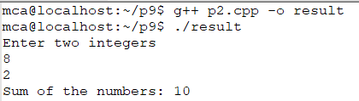

**Study of AWK**

AWK – patten scanning and text processing language

AWK name comes from the last initials of the three authors Aho, Kernighan and  Weinberger. AWK program is a sequence of pattern {action} pairs  and  function  definitions.  Short programs are entered on the command line usually enclosed in ' ' to avoid shell interpretation.  Longer programs can be read  in  from  a  file with the -f option.  Data  input is read from the list of files on the command line or from standard input when the list is empty.  The input is broken  into records  as  determined by the record separator variable, RS.  Initially, RS = "\n" and records are synonymous with lines.  Each record is  compared  against each pattern and if it matches, the program text for {action} is executed.

**Syntax:**

awk program [file] - where program is composed of one or more pattern {action}

**Options:**

-F value     sets the field separator, FS, to value.

-f file          Program  text  is  read  from  file instead of from the command line.  Multiple -f options are allowed.

-v var=value   assigns value to program variable var.

**INPUT**

This is India

This is Maharashtra

This is Mumbai

This is Chembur

This is VESIT

This is first year MCA

**OUTPUT**

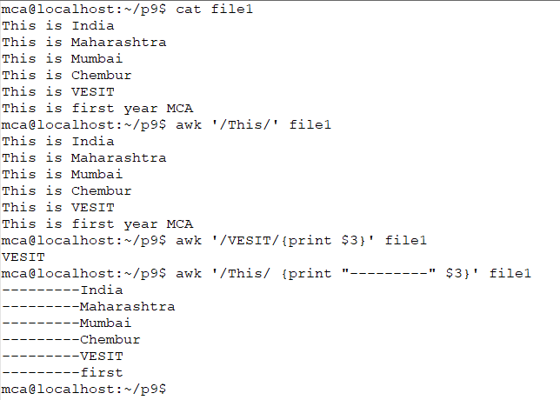

**INPUT**

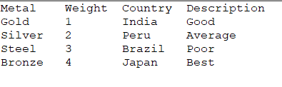

**OUTPUT**

